**People Analytics**

**Headcount and Voluntary Attrition Analysis of an IT Company based on data received from HR Talent Team**

**Talent Management**

People Analytics is relatively a newer branch of Data Analytics which involves gathering HR Talent data and perform analysis on various aspects of HR Functions including Talent Headcount and Resource Capacity, Hiring, Performance Management, Learning, Skill Growth, Appraisals, Attrition etc.

Large Corporates with their Talent spread around the globe and the requirement of the HQ Leadership Team to have timely updates on their Talent Resources is absolutely critical to their business. While some companies have been using this for several years, others have realized the potential of these Analysis to their Business. The work done by such teams is presented not only to the level of HR Leadership but also to CEOs.

For this project, we will be focussing on analysing Talent Headcount and Attrition Analysis. Now Headcount and Attrition are focus areas of Talent Management and there is always higher priority given to these two in Talent scenarios.

Attrition rate, also referred to as turnover rate is an undesirable feature of today’s corporate world. High voluntary attrition rate is a drain on the resources of an organization. A new hire would take a long time to come up to the speed of employee who left and this case slow down organization performance while draining the resources. As per calculations of a large US IT group, a new Hire on average takes at least 6 months to become productive and average cost of training is 35,000 USD or Euro 32,000. This cost is significant and if Managers can retain their talent, it helps the organisation at all levels to manage their Talent.

Generally, voluntary attrition is caused by following reasons:

1. Better Opportunity
2. Career Growth
3. High Stress and Work Life Balance
4. Lack of Opportunity in current Role
5. Performance related issues

We will analyse the data from HR Talent team to find the root cause of high attrition rates and pinpoint the areas they need to focus on to control the attrition.

To analyse the data, we will perform series of steps including data checking, cleaning, and preprocessing with Python Pandas operations. This will be followed by calculating the summary of current headcount, losses count and attrition rates.

We will be analysing the data using matplotlib and seaborn libraries to visualize the data in meaningful manner and bring out the key points.

Finally, all the visualization will be shared with Talent Management Leadership team using a **Streamlit** **framework** Web Dashboard. This Dashboard will help them review the data with visualizations. Moreover, whenever new HR data file is provided by the HR team, it can be provided to system, and the Dashboard will show updated information. For example, the Dashboard can be updated weekly or monthly based on requirement of the Leadership.

**Data cleaning and preprocessing**

The data file received from HR Department does not include any employee identifier like Employee number, email, or any other way to identify individuals due to GDPR. Such data has either been masked or removed. However, the file contains all required data required to perform HC and Attrition Analysis.

DataInformation using the **.info()** function

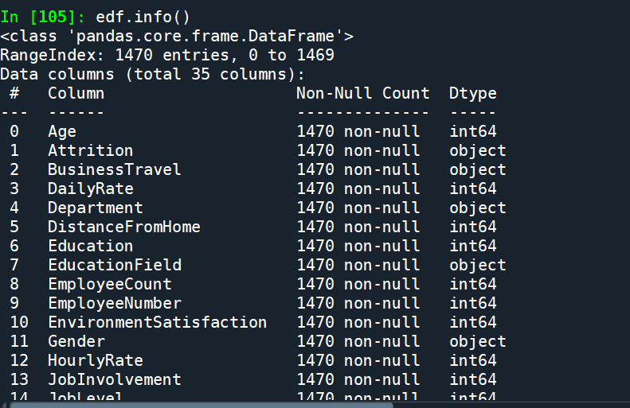

Checking for null values for all columns using .isnull().sum()

The function shows no null values in any column indicating that data is quite clean

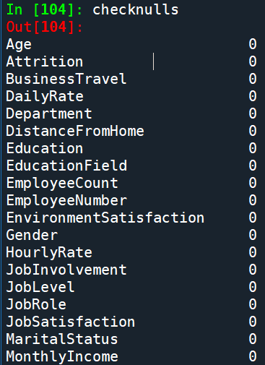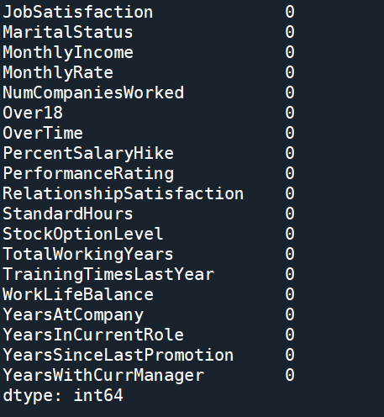

**Binary classification**

Some data fields have categorical values, example Yes/No. We change these values to binary values

1 / 0 to ensure that we can summarize the data required to perform the analysis.

**Exploratory Data Analysis**

Correlation Heatmaps. This is a good starting point if you are looking for patterns in the dataset and helps to find out any co-related variables.

**Summary Headcount and Attrition Analysis**

Attrition rate is calculated by the industry standard formula.

**Attrition rate% = (Losses/Headcount) * 100**

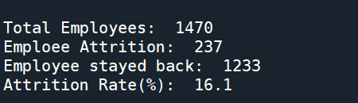

**Data visualization using Python**

**Headcount Analysis**

**Headcount by Department**

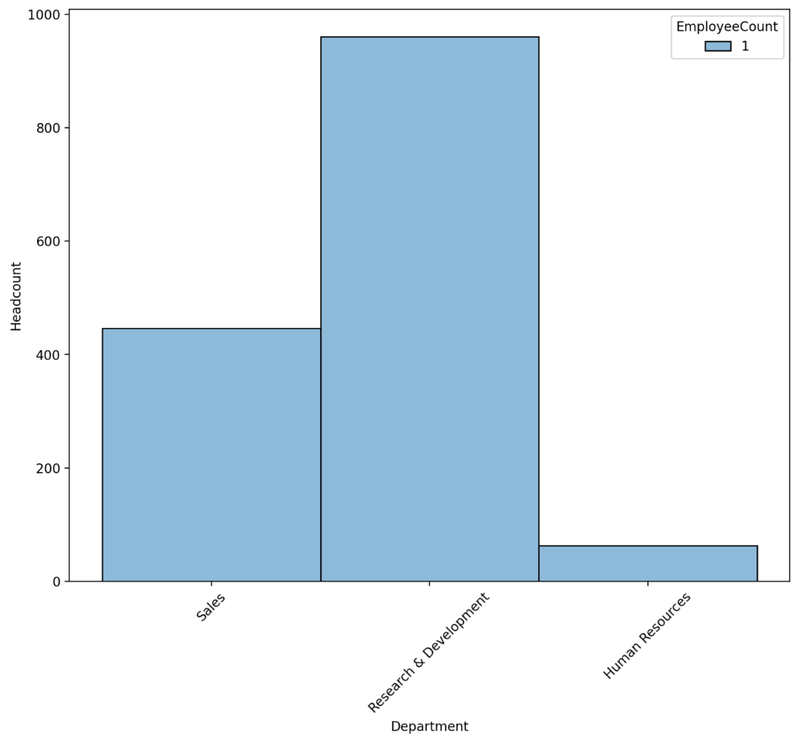

**HC distribution by Age group**s

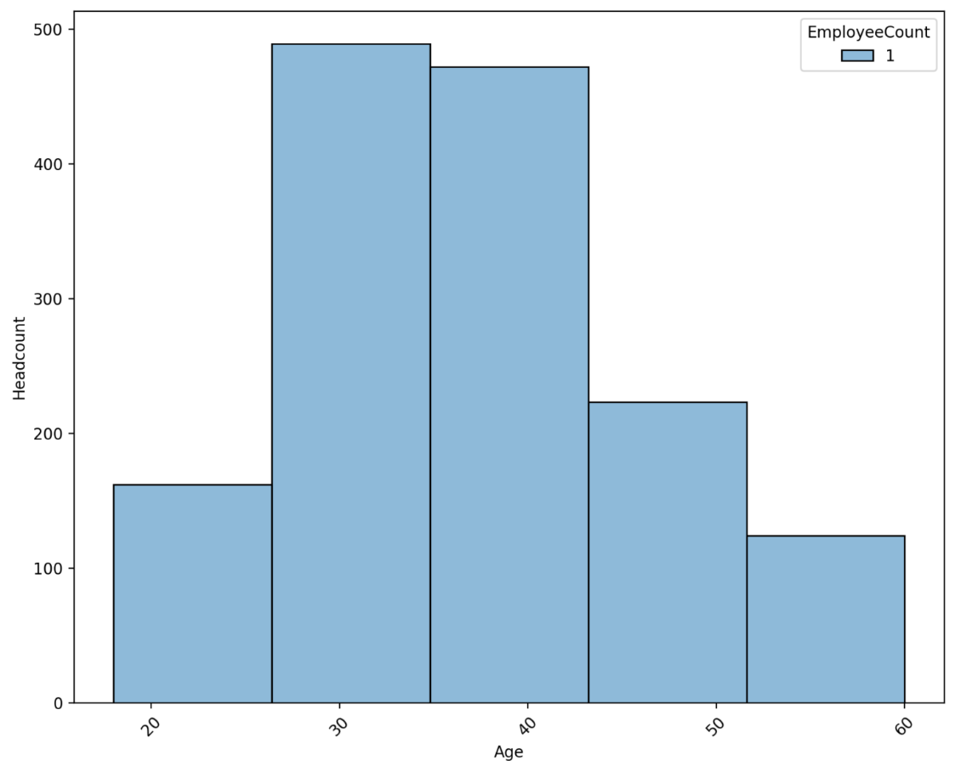

**HC distribution by Monthly Income groups**

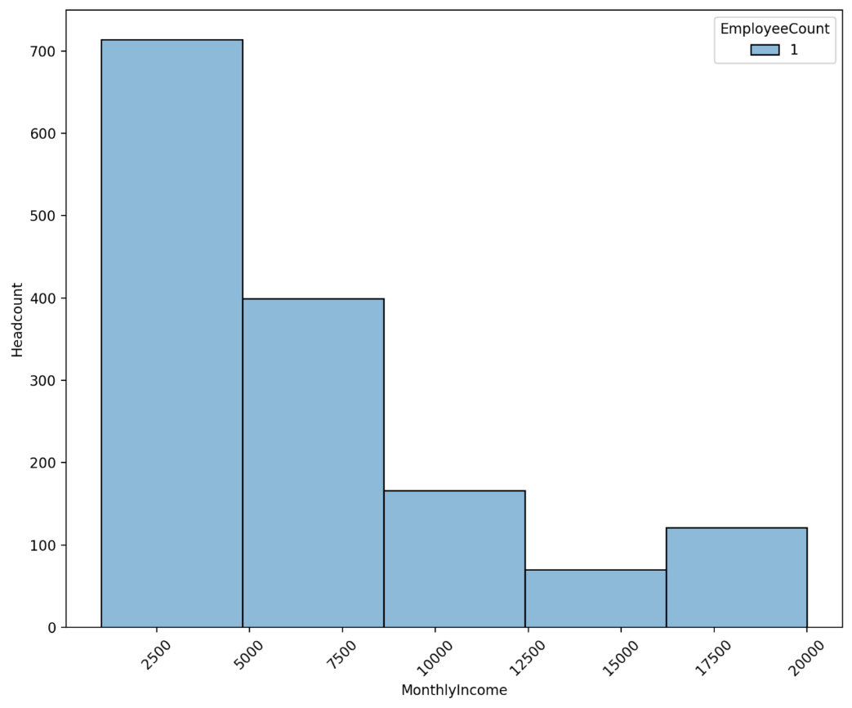

**HC distribution by Tenure (Years with Organization)**

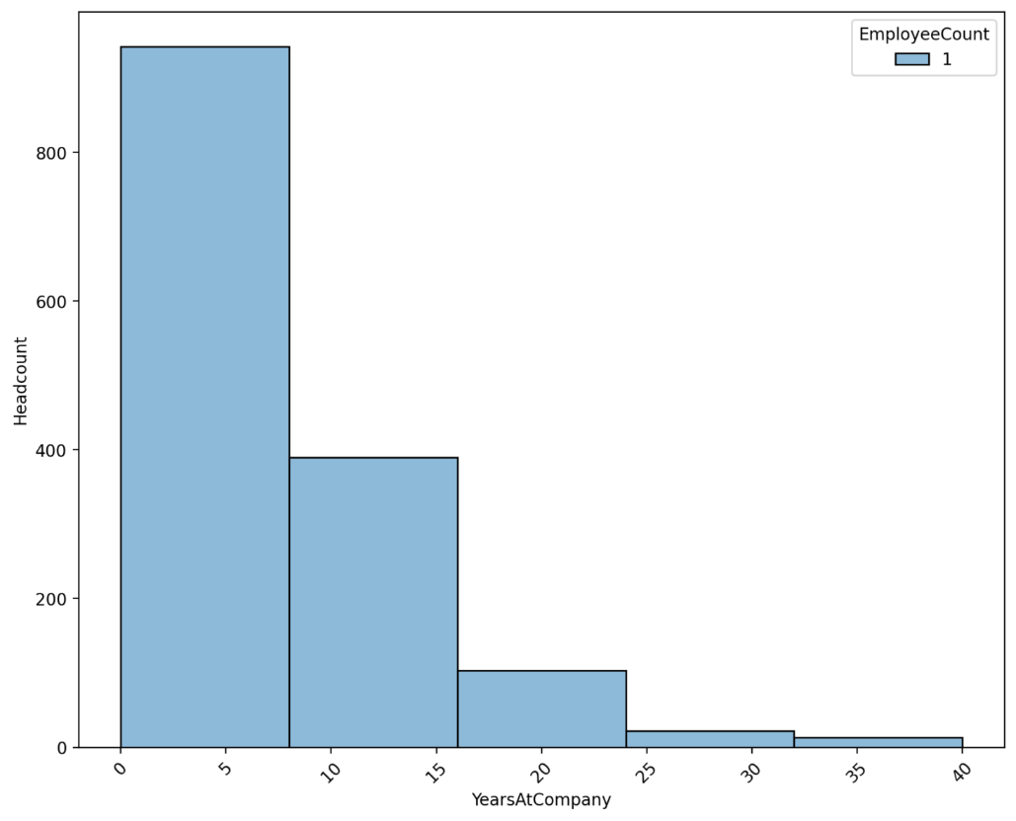

**Headcount by Diversity (Gender)**

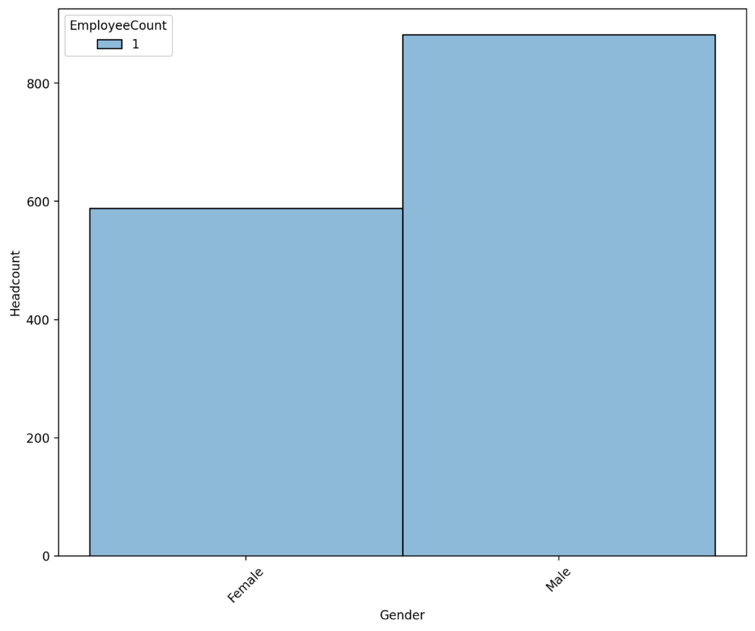

**Voluntary Attrition Analysis**

**Attrition by Department**

**Sales department has a high attrition rate**

**Attrition by Education Level ( 1 being lowest and 5 highest level)**

**Attrition by Ages:**

>> Shows high attrition in age group 26 - 35

**Attrition by Diversity (Gender)**

**Attrition by Job Roles**

Attrition for Sales Rep Job Role is very high if we consider the HC of this department. Loss rates or attrition rates are very high for this department.

**Attrition by Tenure with Organization (Years of Service)**

Attrition is high for newer employees and is quite high for lower tenures (0-2 years with organization)

**Attrition by Job Satisfaction**

Lower job satisfaction scores indicate higher loss or attrition rates.

**Attrition for HC Overtime**

(0=No Overtime, 1= Yes Overtime)

**Conclusion and recommendations**

As per the data analysis of Talent Management, clearly there are reason for higher attrition that would require focus:

1. Sales Department – Deep dives and meeting with Managers required to find out the reasons of high turnover in Sales Department.
2. New employees in 0-5 tenure are leaving more than higher tenure employees. Are there any specific reasons. Carry detailed interviews with employees who are leaving.
3. Age group – Focus on new hires why University hires/Early Professional Hires are leaving faster.
4. Arrange interviews with employees doing Overtime as data shows that employees doing overtime are leaving at faster rate.
5. Female employees have lower attrition rates as compared to males. Hiring strategies should focus on Diversity to have a better Talent Management strategy.

It can be concluded that Talent Management Analysis is crucial to survival and growth of an organization. Such analytics provide the Leadership with key focus areas so that Talent Retention teams can formulate on reducing voluntary attrition and thus provide outflow of key resources but also cut costs and maximize profits.